**Name:** Muhammad Zubair

**Reg no:** FA20-BCS-041

**Course:** Compiler Construction

**Tutor:** Mr. Bilal Haider Bukhari

**Dated:** 28 December, 2023

**Question 2: 2 functionalities along with screen shorts (function code +output)**

**Function**

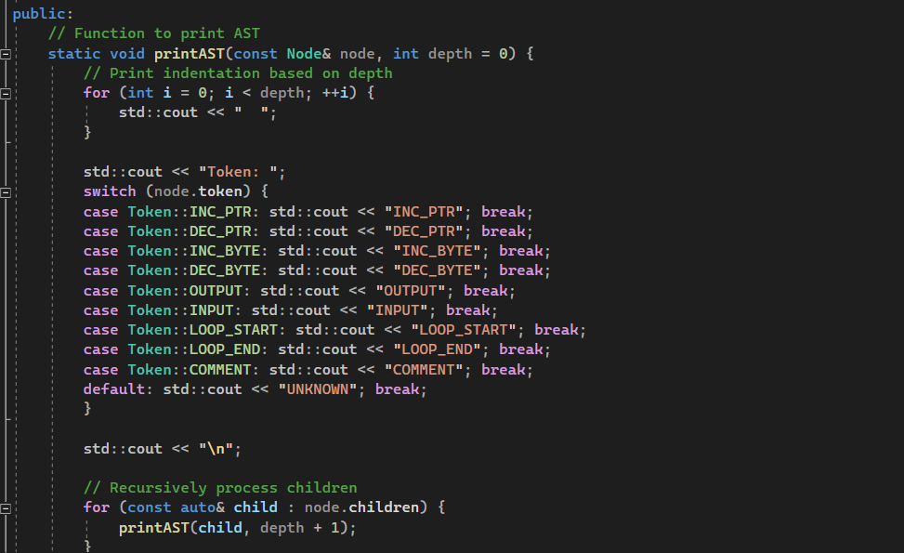

**output**

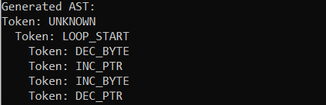

**Function:**

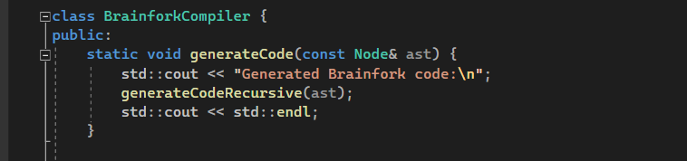

**Output:**

